- Using the Segments of the General Environment, write an environmental analysis for the company Apple
- Please address ALL 4 parts listed below.
- A minimum of 500 words
- Prepare this assignment according to the APA guidelines
- At the bottom of this document there is a section called “Other useful information” that includes screenshots from the textbook and an overview of the company Apple. Refer to it as needed to help you complete the assignment.

- Incorporate the Five Forces of Competition to help write the industry analysis for your organization (Figure 2.2 The Five Forces of Competition Model).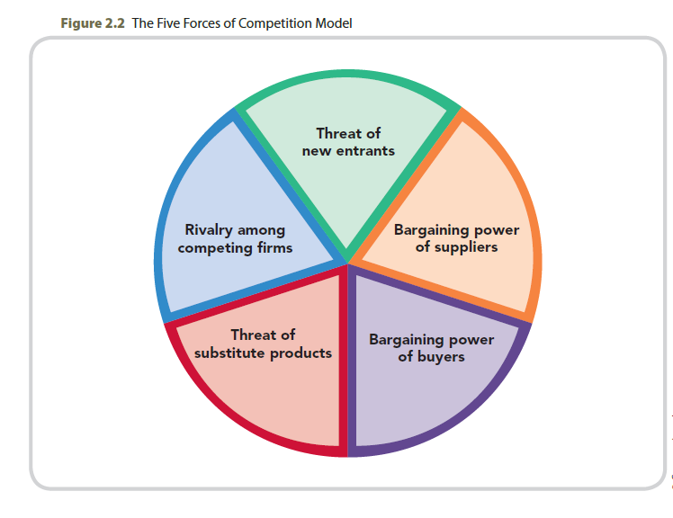
- Describe your sources of competitive advantage.
- Using the Modes of Entry and their Characteristics (Chapter 8, Figure 8.5), describe which mode(s) of entry you would use to expand globally and why you selected it (even if expansion is hypothetical at this time). Select one country, such as Canada, and discuss relevant cultural, political, and economic factors, and any language barriers that could impact your entry.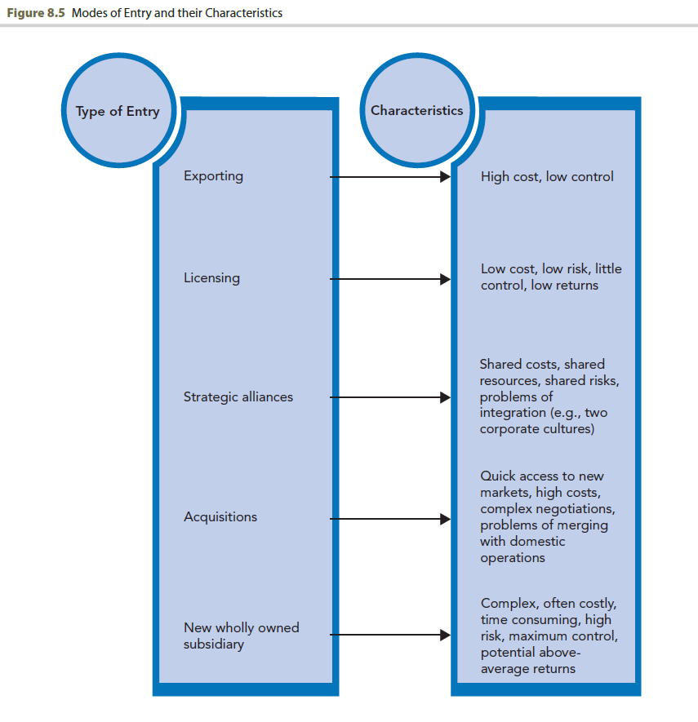
- Using the Parts of the External Environmental Analysis (Chapter 2, Figure 2.1 and Table 2.2), identify the outlook, forecast, or trends for the type of organization you have selected.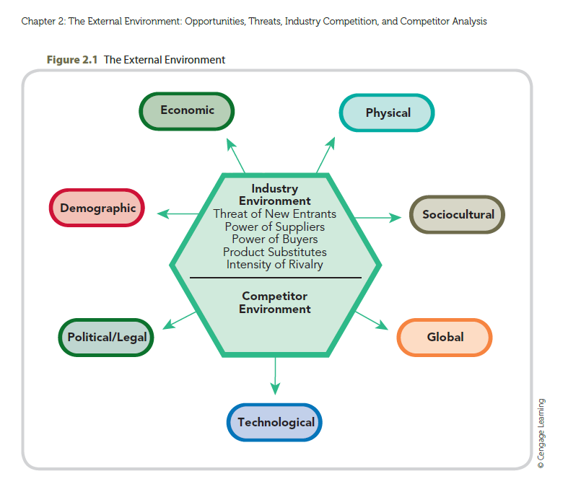

Other Useful information
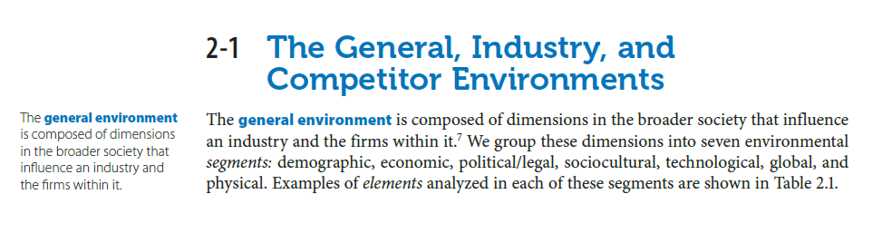

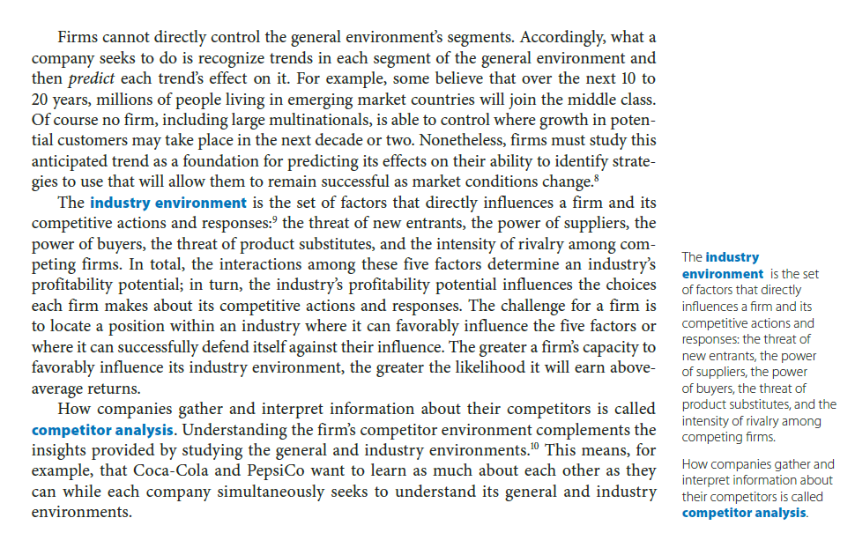
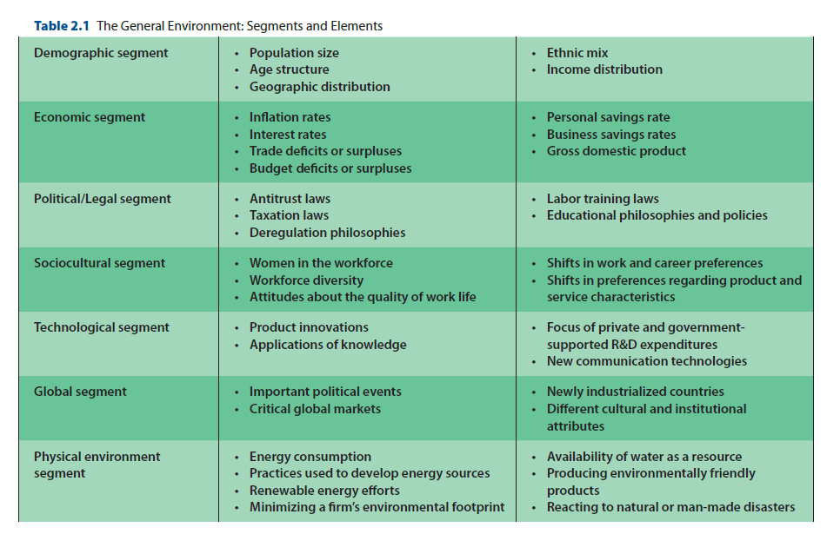

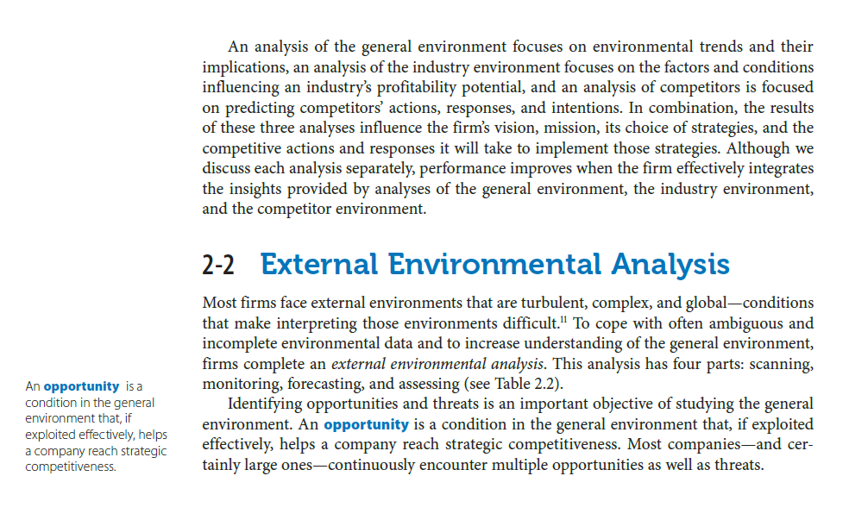

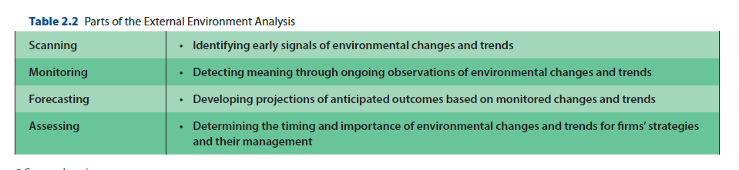

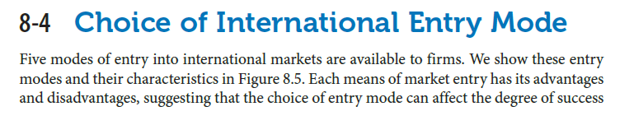

Overview
Apple is one of the most valuable and popular company not only in America but all over the world. Apple computers was founded in 1976 by Steve Jobs and Steve Wozniak. Jobs and Wozniak brought vision of changing the way people viewed computers—a user friendly computer, small enough for people to have them in their homes or offices. Apple Computer, Inc. went public in 1980 and Wozniak left Apple in 1983. Jobs decided to make some changes around Apple in 1997, he revamped the computers and introduced the iBook, iPod, and itunes--iPod and iTunes have become the company’s most profitable sector. Then, Apple released the iPhone and Apple TV (Apple, n.d.).
Context of Apple
Apple has been successful throughout the many years of being a global company and has done so by changing with society. Although Apple’s mission statement has changed throughout the years there has always been the same goal: redefining the future of mobile devices. The company’s current mission statement explains that Apple designs the best personal computer and software there is to date. Moreover, the company has reinvented mobile phones through iPhones and are continuing to reinvent with their iPads. Apple’s mission statement focuses on the company’s successful products such as the iPhone, iPad, iPod, and iBook (Rowland, 2019). Apple wants its customers to know that their mission is to reinvent in order to improve the relationship between the user and the technology around us.
Apple’s Vision and Mission
Apple’s vision statement is similar to its mission which is to continue creating products that are nothing but great. Their vision embodies what every customer wants to hear from a company, that they believe in focusing on what is truly important to the company and their customers. Apple’s vision statement also includes that they are not one to participate in markets that they can't make an impact in. The company is always focusing on innovating and even turning down multiple projects in order to focus on the few that really matter (Rowland, 2019).
Apple's Strategy
Apple has a very successful strategy that pushes the organization to the top of a very competitive industry. By creating product and services that customers value Apple is able to capitalize on the productivity that the company maintains. Apple has a wide range of product that creates a large selection for any consumer base. Having a large consumer base allows the organization to reach a broader range of targeted consumers to up the sales in products and services. Apple aims to create products for their consumer base that are not just an appealing product but also a very user friendly for new users. With reliable and flawless products the marketing side of the Apple industry is able to showcase the product as a highly valued product. Part of Apple’s strategy is to, “provide highly differentiated products to a wide range of customers” (Competitive Strategy, 2017). The variety that Apple is able to offer to their customers excels the organization to have great success in the industry.
Nature of Business Opportunity
In order for Apple to have continuous success the company is looking to grow even more internationally. While sticking with their vision of redefining mobile devices year in and year out. This starts with Apple taking a step back as stated and looking to countries and different markets that are not currently being accessed. For example, in Africa Apple could look to create a newer device that enables better communication for a more affordable price due to the market’s low income. Competitively Apple is still on top, but in order for them to stay there, they’re going to have to continue to find new ways of integrating newer technology not only in their successful regions but newer regions of the world as well. Overall the goal of this business venture is too look to lesser markets and find new ways to reach out and improve upon their technology through Apple products.

